Unique Tennis Academy Child Protection Policy

CONCERN REPORTING PROCEDURE

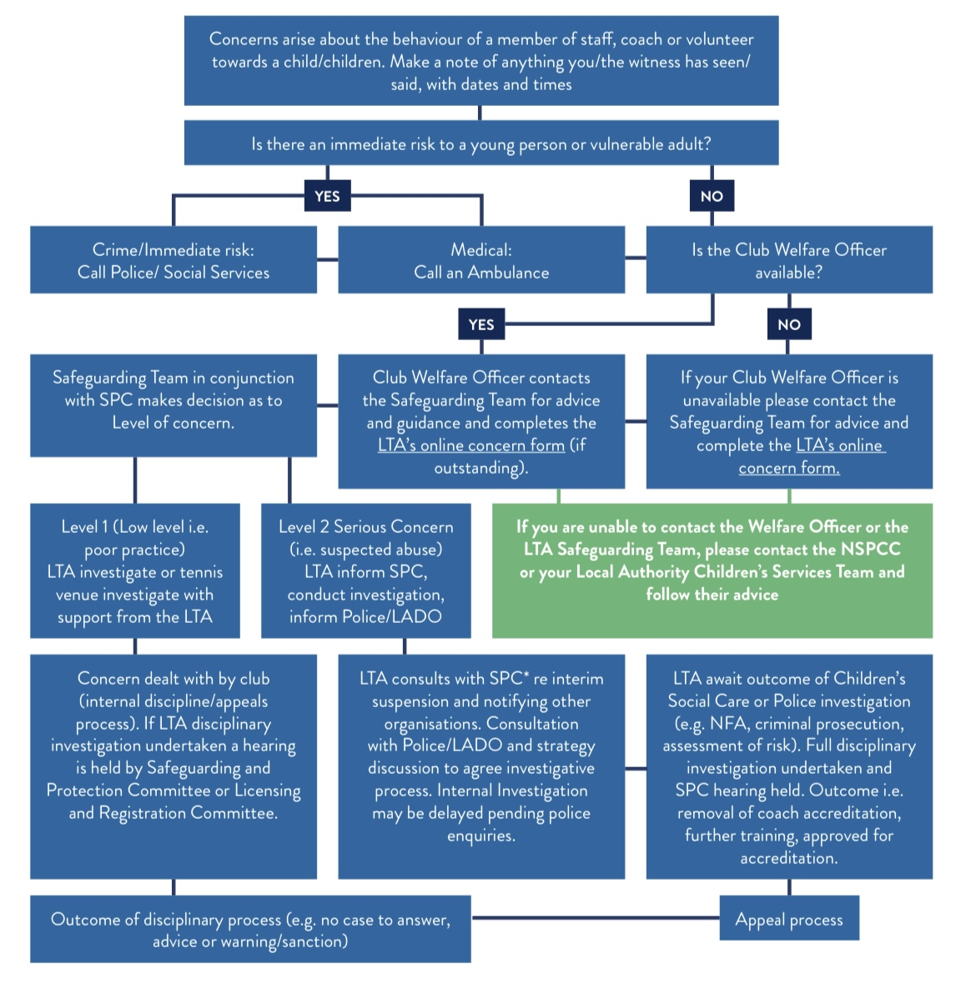
Anyone who is concerned about the well-being of a child/ adult at risk, or has a disclosure of abuse or neglect made to them must:
POLICY STATEMENT

Unique Tennis Academy is fully committed to safeguarding the welfare of all children and adults at risk in its care. It recognises the responsibility to promote safe practice and to protect children from harm, abuse and exploitation. This Policy, Standards and Code of Conduct strive to minimise risk and support the academy and all individuals to deliver
a positive tennis experience for everyone. The Reporting a Safeguarding Concern Procedure outlines how to respond to safeguarding concerns/disclosures.
Unique Tennis Academy recognises that it has a legal responsibility to safeguard children and adults at risk, including due regard to the need to prevent people from being drawn into extremism and terrorism (the Prevent Duty). Staff and volunteers will work together to embrace difference and diversity and respect the rights of children and adults at risk.
Ultimately this document outlines Unique Tennis Academy’s commitment to protecting young people and adults at risk.

USE OF TERMINOLOGY

Child: a person under the age of eighteen years.

Adult at risk of abuse or neglect: an adult who: has care and support needs; is experiencing, or is at risk of abuse or neglect; and because of their care and support needs cannot protect themselves against actual or potential abuse or neglect.

Safeguarding children: protecting children from abuse and neglect, preventing the impairment of.

children’s health or development, preventing children from being drawn into extremism and/or terrorist activity, ensuring that they grow up in circumstances consistent with the provision of safe and effective care, and taking action to enable all children to have the best life chances. Recognising that some children may be more vulnerable to abuse or neglect, such as children with disabilities.

Safeguarding adults at risk: protecting adults from abuse and neglect and preventing them from being drawn into extremism and/or terrorism. Enabling individuals to achieve the outcomes that matter to them in their life; protecting their right to live in safety, free from abuse and neglect. Empowering and supporting them to make choices, stay safe and raise any concerns.

Beginning with the assumption that an individual is best-placed to make decisions about their own well- being, taking proportional action on their behalf only if someone lacks the capacity to make a decision;

is exposed to a life-threatening risk; someone else may be at risk of harm; or a criminal offence has been committed or is likely to be committed.

SCOPE

Unique Tennis Academy has direct safeguarding responsibility for:

• Staff, consultants, coaches and officials they employ;
• Volunteers, including board members and councillors they recruit;
• Venues they run the programme from;
• Events and programmes they run; and
- Ensuring all accreditation requirements are met by accredited coaches, officials and venues.

Unique Tennis Academy recommends and supports the development of good safeguarding practices to:

• Accredited coaches, officials and venues;
• Players, parents and carers;
• Volunteers recruited.
• Venues hired by or on behalf of Unique Tennis Academy
• Events supported by Unique Tennis Academy

This Policy, Standards, Code of Conduct and Reporting a Safeguarding Concern Procedure are in line with national legislation, Working Together to Safeguard Children 2018 and applicable across the UK, to every person and place that Unique Tennis Academy has direct safeguarding responsibility.

Guidance on implementing the Safeguarding Standards is outlined in Implementing the Safe and Inclusive Tennis Standards.

RESPONSIBILITY FOR THE IMPLEMENTATION OF THE SAFEGUARDING POLICY, STANDARDS, CODE OF CONDUCT AND REPORTING A SAFEGUARDING PROCEDURE

SAFEGUARDING IS EVERYONE’S RESPONSIBILITY: NOT RESPONDING TO A SAFEGUARDING CONCERN IS NOT AN OPTION.

- Unique Tennis Academy’s directors have overall accountability for this Policy, Standards, Code of Conduct and Reporting a Safeguarding Concern Procedure
• The Directors have overall responsibility for its implementation.
- Unique Tennis Academy’s Head of Safeguarding is responsible for updating this Policy, Standards, Code of Conduct and Reporting a Safeguarding Concern Procedure in line with legislative and organisational developments.
- Unique Tennis Academy’s Head of Safeguarding is responsible for supporting their team to identify where safeguarding support is required; to implement safeguarding procedures in the team
- All staff, consultants, coaches, officials and volunteers are responsible for raising safeguarding concerns/disclosures with the Unique Tennis Academy’s head of Safeguarding as outlined in the Reporting a Safeguarding Concern Procedure
- Players, parents and carers are responsible for upholding the Safe and Inclusive Code of Conduct and Reporting a Safeguarding Concern Procedure
- The head of Safeguarding is responsible for ensuring appropriate safeguarding training is put in place for new joiners and to ensure that existing members of staff are kept up to date with any safeguarding developments.
- The Head of Safeguarding has particular responsibility for the Prevent Duty relating to ensuring that adults and children are not drawn into extremism or terrorist actions

Where there is a safeguarding concern/disclosure:

- The individual who is told about, hears, or is made aware of the concern/disclosure is responsible for following the Reporting a Safeguarding Concern Procedure
- The head of Safeguarding is responsible for reporting all safeguarding concerns to the LTA Safeguarding Team.
- The LTA Safeguarding Team will then be responsible for assessing all safeguarding concern/ disclosures that are reported to them and working with the head of safeguarding to follow up as appropriate on a case-by-case basis, prioritising the well-being of the child/ adult at risk at all times. Dependent on the concern/disclosure, a referral may be made to:
• The police in an emergency (999);
- Local Authority Children’s Social Care Services for concerns/|disclosures about a child;
- Local Authority Adult Social Care Services for concerns/disclosures about an adult at risk;
- Designated Officer (England; Wales); and national Disclosure and Barring Service for concerns/disclosures about a member of staff, consultant, coach, official or volunteer; and/or
• The LTA Safeguarding and Protection Committee for advice and decisions;
- and/or
- The police Prevent Officer for concerns about children or adults at risk of being drawn into extremism or terrorist activity and Channel with permission from the individual and parent/carer for those under eighteen years old.

BREACHES OF THE SAFEGUARDING POLICY, STANDARDS, CODE OF CONDUCT AND REPORT- ING A SAFEGUARDING CONCERN PROCEDURE

Where there are concerns that safeguarding good practice has not been followed, all staff are encouraged to follow the whistleblowing policy; consultants, coaches, officials, volunteers and players are encouraged to follow Unique Tennis Academy’s whistleblowing procedure. Alternatively the LTA Safeguarding Team can be contacted on safeguarding@LTA.org.uk. The NSPCC Whistleblowing advice line can also be contacted at 0800 028 0285 or help@nspcc.org.uk .

Breaches of this Policy and/or failure to comply with the outlined responsibilities may result in the following by Unique Tennis Academy:

- Staff - disciplinary action leading to possible dismissal and legal action;
- Contracted consultants, officials and coaches - termination of current and future roles within the academy.
- Recruited volunteers, including councillors and board members - termination of current and future roles within the academy.

Actions taken by staff, consultants, volunteers, officials, coaches, venues, and/or events outside of Unique Tennis Academy that are seen to contradict this Policy may be considered a violation of this Policy.

Where an appeal is lodged in response to a safeguarding decision made by Unique Tennis Academy, an independent appeal body such as Sport Resolutions may be used in accordance with the LTA Safeguarding Procedures. Their decision is final.

SAFE AND INCLUSIVE TENNIS STANDARDS

The Standards aim to set a minimum level of practice to promote and support safeguarding, diversity and inclusion in tennis. Implementing the Safe and Inclusive Tennis Standards is intended to be used alongside this Policy, Code of Conduct and Reporting a Safeguarding Concern Procedure; and the Diversity and Inclusion policy.

STANDARD 1

We have Safeguarding, Diversity and Inclusion Policies and a Code of Conduct that applies to all staff, consultants, coaches, officials, volunteers, venues and events.

- All staff, consultants, volunteers, officials, coaches, and events follow our Safeguarding, Diversity and Inclusion Policies, Standards, Code of Conduct and Reporting a Safeguarding Concern Procedure.
- Our policies and procedures are risk assessed, monitored and updated.

STANDARD 2

We empower children and adults to create safe and inclusive tennis environments, both on and off court.

- We support everyone to uphold the Fair Play values.
- Information, resources and guidance on how to stay safe, promote safeguarding, diversity and inclusion and report concerns is easy to access, understand and implement.
- There is a resourced Safeguarding Team; named Welfare Officers and named officials responsible for creating a safe and inclusive tennis environment at Unique Tennis Academy.
- Children and adults are actively encouraged to report any concerns they have about themselves or others; those who report concerns are protected and supported.

STANDARD 3

We prioritise safe and inclusive recruitment, induction, training and support.

- All applicable applications, interviews and references address safeguarding, diversity and inclusion requirements and attitudes.
- All eligible staff, consultants, volunteers, accredited officials and coaches have a criminal records check.
- All Unique Tennis Academy’s staff, accredited officials, accredited coaches, Welfare Officers, relevant consultants and volunteers receive appropriate safeguarding, diversity and inclusion training and on-going support.

STANDARD 4

We protect people’s confidential information about safeguarding, diversity and inclusion.

- Confidential information relating to safeguarding, diversity and inclusion is:
• Stored securely
• Accessed and processed securely
• Shared securely and appropriately.

STANDARD 5

We address safeguarding and discrimination concerns immediately, prioritising the well- being of children and adults at risk.

- All concerns, including on-line concerns (cyber-bullying, sexting, grooming, extremism, radicalisation and all other forms of on-line abuse) are recognised, reported and responded to.
- All safeguarding and discrimination concerns/allegations made regarding a Unique Tennis Academy’s member of staff will follow our disciplinary procedure and may be reported to external authorities.
- All concerns are reported immediately, following the Reporting a Safeguarding Concern Procedure.
- We foster a collaborative approach to safeguarding, diversity and inclusion at Unique Tennis Academy and with other agencies.

SAFE AND INCLUSIVE CODE OF CONDUCT

- Prioritise the well-being of all children and adults at all times
- Be a positive role model. Act with integrity, even when no one is looking.
- Help to create a safe and inclusive environment both on and off court and promote the Fair Play values.
• Value and celebrate diversity and make all reasonable efforts to meet individual needs.
- Keep clear boundaries between your professional and personal life, including on social media
- Check you have the relevant consent from parents/carers, children and adults before taking or using photos and videos.
- Ensure your own roles and responsibilities, and those of everyone you are responsible for, are clearly outlined and everyone has the information, training and support to carry them out.

WHERE POSSIBLE, DO NOT BE ALONE WITH A CHILD OR ADULT AT RISK

- Do not abuse, neglect, harm , radicalise, draw into extremist behavior, or discriminate against anyone; or act in a way that may be interpreted as such.
- Doing nothing is NOT an option: report all concerns and disclosures as soon as possible, following the Reporting a Safeguarding Concern Procedure. If someone is in immediate danger, call the police (999).

*It is illegal to have a relationship with someone who is under 18 years old if you are in a position of trust; it is illegal to have a sexual relationship with anyone under the age of 16 whether they give consent or not.

The Code of Conduct should be interpreted in a spirit of integrity, transparency and common sense, with the best interests of children and adults at risk as the primary consideration.

APPENDIX A: GLOSSARY OF TERMS ABUSE AND NEGLECT

- Physical abuse: a form of abuse which may involve hitting, shaking, throwing, poisoning, burning or scalding, drowning, suffocating or otherwise causing physical harm to a child or adult at risk. Physical harm may also be caused when a parent or carer fabricates the symptoms of, or deliberately induces illness.
- Sexual abuse: involves forcing or enticing a child or adult at risk to take part in sexual activities, not necessarily involving a high level of violence, whether or not the child or adult at risk is aware of what is happening. The activities may involve physical contact, including assault by penetration (for example, rape or oral sex) or non-penetrative acts such as masturbation, kissing, rubbing or touching outside of clothing. They may also include non-contact activities, such as involving children/ adults at risk in looking at, or in the production of, sexual images, watching sexual activities, encouraging them to behave in sexually inappropriate ways, or grooming someone in preparation for abuse (including via the internet). Sexual abuse is not solely perpetrated by adult males. Women can also commit acts of sexual abuse, as can children.
- Emotional abuse: the persistent emotional maltreatment of a child or adult at risk such as to cause severe and persistent adverse effects on their emotional development. It may involve conveying to a child/ adult at risk that they are worthless or unloved, inadequate, or valued only insofar as they meet the needs of another person; not giving them opportunities to express their views; deliberately silencing them or ‘making fun’ of what they say or how they communicate. It may feature age or developmentally inappropriate expectations being imposed, including interactions that are beyond a child or adult at risk’s developmental capability, as well as overprotection and limitation of exploration and learning, or preventing them participating in normal social interaction. It may involve seeing or hearing the ill-treatment of another. It may involve serious bullying (including cyber bullying), causing a child or adult at risk to feel frightened in danger, or exploited. Some level of emotional abuse is involved in all types of maltreatment, though it may occur alone.

- Neglect: the persistent failure to meet a child/ adult at risk’s basic physical and/ or psycho logical needs, likely to result in the serious impairment of their health or development. It may involve a parent or carer failing to:
• provide education, adequate food, clothing or shelter;
• protect a child/ adult at risk from physical or emotional harm or danger;
• ensure adequate supervision (including the use of inadequate care-givers); or
• ensure access to appropriate medical care or treatment.
- It may also include neglect of, or unresponsiveness to, a child’s or adult at risk’s basic emotional needs. Neglect may occur during pregnancy due to maternal substance abuse.
- Radicalisation, extremism and terrorist behaviour: Radicalisation is the process by which a person comes to support terrorism and/or forms of extremism. Extremism is vocal or active opposition to fundamental British values, including democracy, the rule of law, individual liberty and mutualrespect and tolerance of different faiths and beliefs. There is no single way to identify an individual who is likely to be susceptible to extremist ideology. The internet and the use of social media can be a major factor in the radicalisation of people.

ADDITIONAL EXAMPLES OF ABUSE AND NEGLECT OF ADULTS AT RISK

- Financial abuse: having money or property stolen; being defrauded; being put under pressure in relation to money or other property; and having money or other property misused.
- Discriminatory abuse: treating someone in a less favourable way and causing them harm, because of their age, gender, sexuality, gender identity, disability, socio- economic status, ethnic origin, religion and any other visible or non-visible difference.
- Domestic abuse: includes physical, sexual, psychological or financial abuse by someone who is, or has been a partner or family member. Includes forced marriage, female genital mutilation and honour-based violence (an act of violence based.
- On the belief that the person has brought shame on their family or culture). Domestic abuse does not necessarily involve physical contact or violence.
- Psychological abuse: including emotional abuse, threats of harm or abandonment, deprivation of contact, humiliation, blaming, controlling, intimidation, coercion, harassment, verbal abuse, isolation or withdrawal from services or supportive networks.
- Organisational abuse: where the needs of an individual are not met by an organisation due to a culture of poor practice or abusive behaviour within the organisation.
- Self-neglect: Behaviour which threatens an adult’s personal health or safety (but not that of others). Includes an adult’s decision to not provide themselves with adequate food, clothing, shelter, personal hygiene, or medication (when indicated), or take appropriate safety precautions.
- Modern slavery: encompasses slavery, human trafficking, criminal and sexual exploitation, forced labour and domestic servitude. Traffickers and slave masters use whatever means they have at their disposal to coerce, deceive and force individuals into a life of abuse, servitude and inhumane treatment.
• A person who is being abused may experience more than one type of abuse.
- Bullying and harrassment are recognised as forms of abuse.
- Female Genital Mutilation (FGM) is recognised as a form of physical, sexual and emotional abuse that is practised in the UK (and elsewhere).
- Child Sexual Exploitation is recognised as a form of sexual abuse in which children are sexually exploited for money, power or status
- Child trafficking is recognised as child abuse where children are often subject to multiple forms of exploitation. Children are recruited, moved or transported to, or within the UK, then exploited, forced to work or sold.
- People from all cultures are subject to abuse. It cannot be condoned for religious or cultural reasons.
- Abuse can have immediate and long-term impacts on someone’s well-being, including anxiety, depression, substance misuse, eating disorders and self-destructive conducts, offending and anti-social conduct.
- Those committing abuse are most often adults, both male and female. However, child- to- child abuse also takes place.
- Some children and adults may be more vulnerable to abuse. For example, deaf and disabled people; people with mental health problems; new to the UK; or from minority groups (note this list is not exhaustive).

APPENDIX B: WHAT TO DO IF A DISCLOSURE FROM A CHILD OR ADULT AT RISK IS MADE TO YOU

- Listen carefully and calmly to the individual.
- Reassure the individual that they have done the right thing and what they have told you is very important.
- Avoid questioning where possible, and never ask leading questions.
- Do not promise secrecy. Let the individual know that you will need to speak to the Welfare Officer/LTA Safeguarding Team because it is in their best interest. If you intend to speak to the police or social care, you should let them know this too.
- Report the concern. In an emergency, call the police (999), otherwise talk to the Welfare Officer/LTA Safeguarding Team as soon as possible. Do not let doubt/personal bias prevent you from reporting the allegation.
- Record details of the disclosure and allegation using the LTA’s online concern form. If you do not have access to the online form, write down the details using what you have available then sign and date it.

